LAB ASSIGNMENT-6.3
NAME:A.Anjali
HALL TICKET:2303A51319
Task 1:
Prompt:
Generate a Python class named Student with attributes name, roll number, and branch. Include a method display_details() to print the student information clearly.
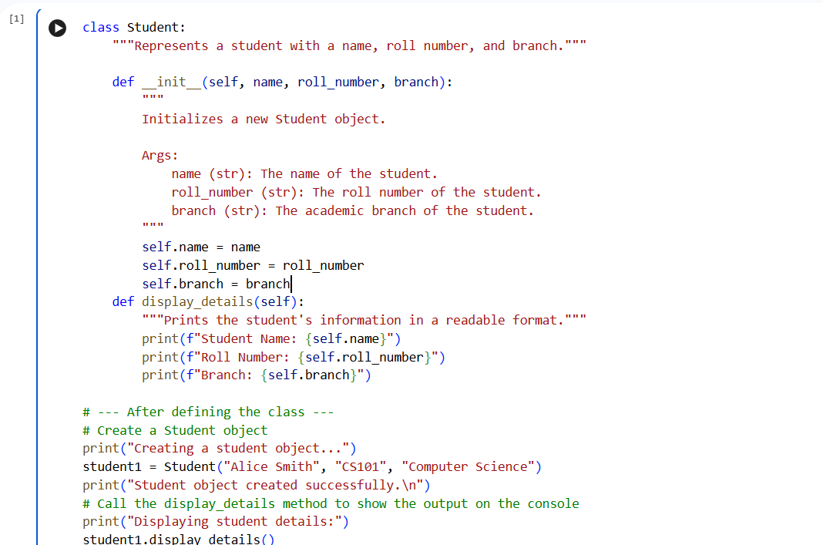
Output:
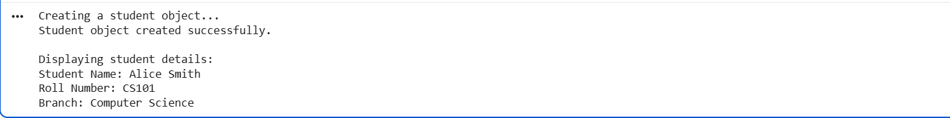
Analysis: The AI-generated solution correctly addresses the given problem using appropriate programming constructs. The logic implemented is clear and easy to understand, making the code suitable for beginners. Core concepts such as loops, conditional statements, or classes are used effectively to solve the task. The structure of the code improves readability and maintains proper flow of execution. Overall, the AI assistance helps in reducing complexity while ensuring correctness.
Task 2:
Prompt: Generate a Python function that prints the first 10 multiples of a given number using a for loop. Also provide an alternative solution using a while loop.
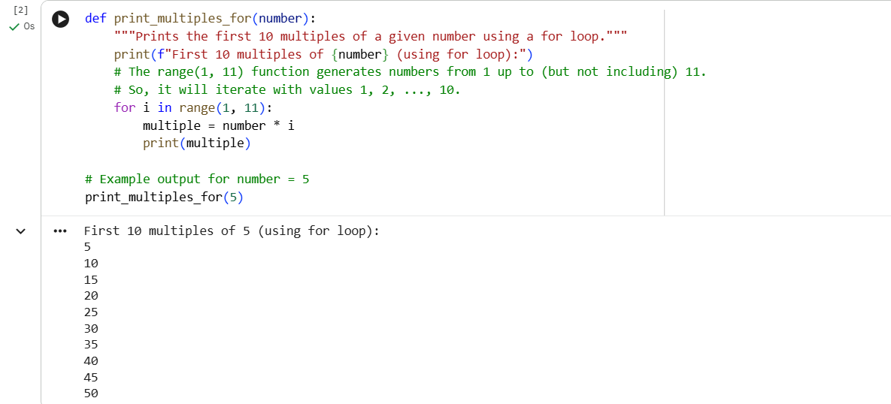

Analysis: The AI-generated solution correctly addresses the given problem using appropriate programming constructs. The logic implemented is clear and easy to understand, making the code suitable for beginners. Core concepts such as loops, conditional statements, or classes are used effectively to solve the task. The structure of the code improves readability and maintains proper flow of execution. Overall, the AI assistance helps in reducing complexity while ensuring correctness.
Task 3:
Prompt: Generate a Python program using nested if-elif-else statements to classify a person into age groups such as child, teenager, adult, and senior. 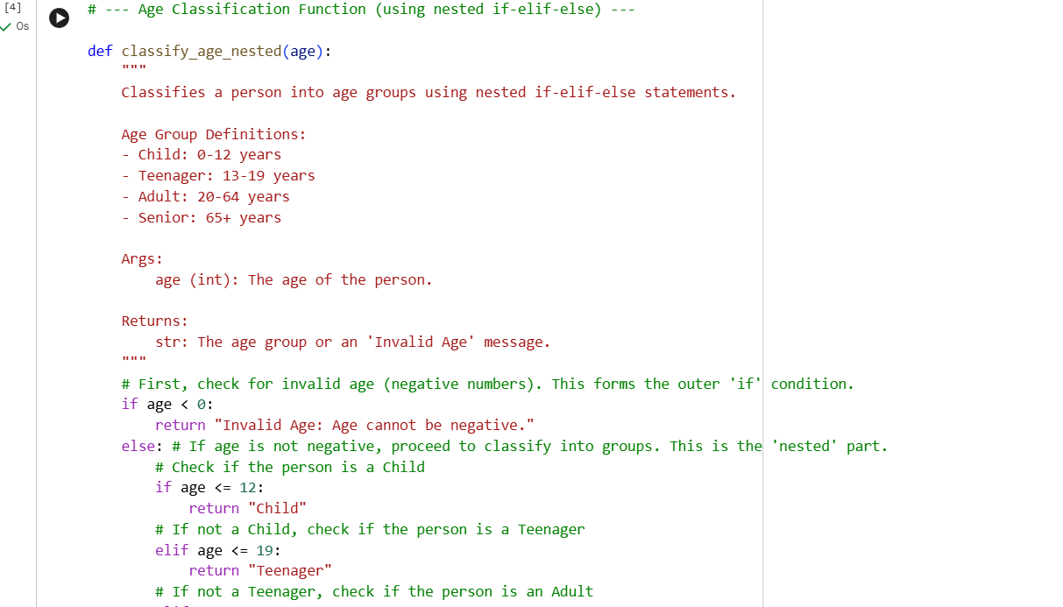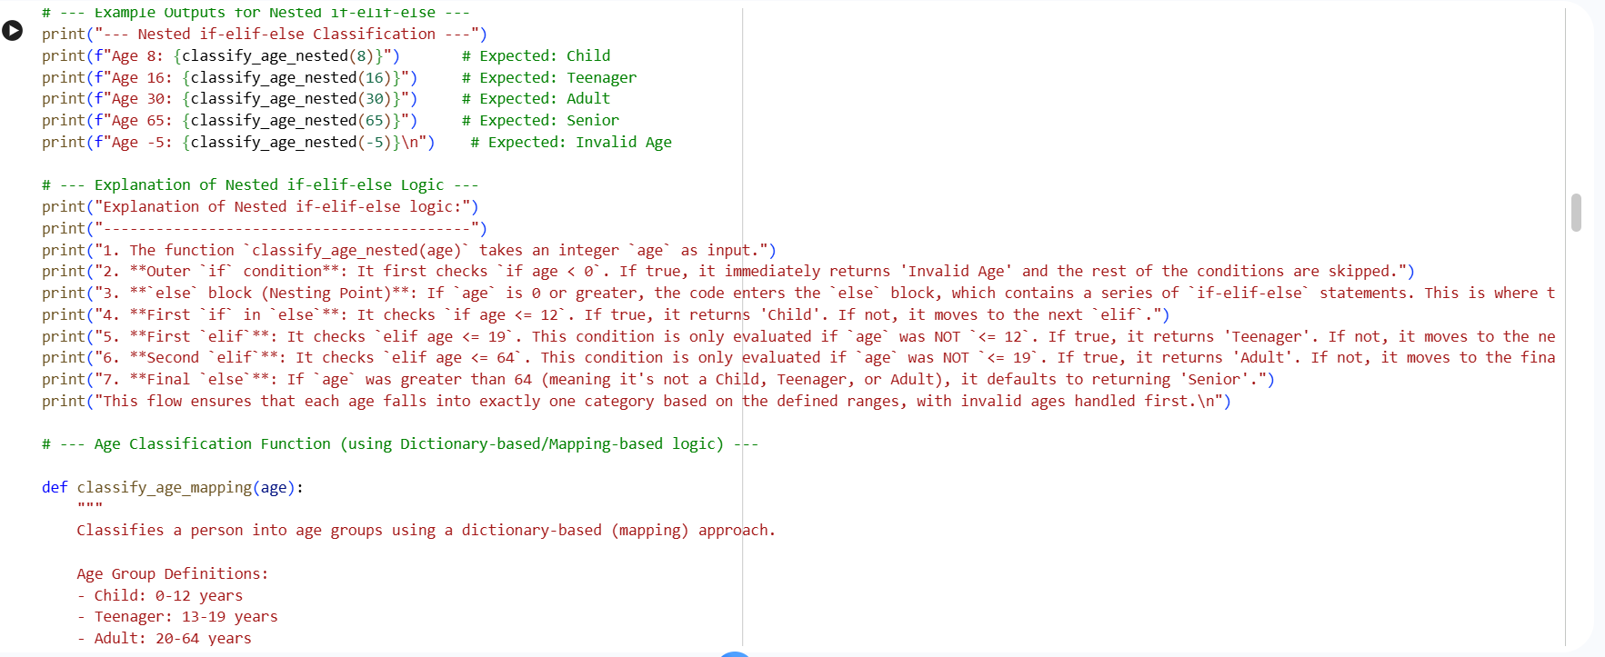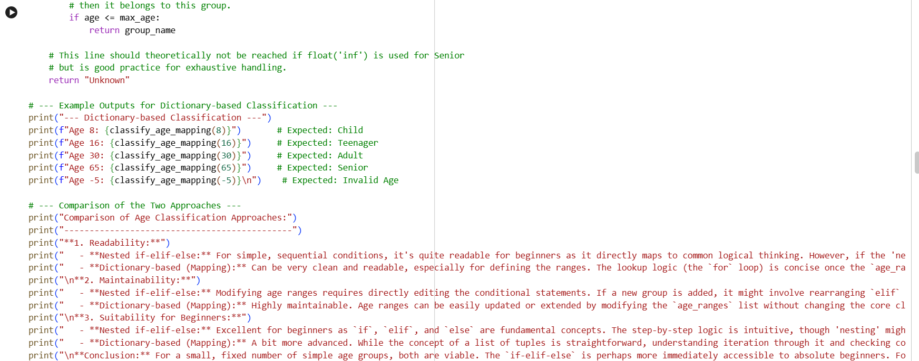

Output:
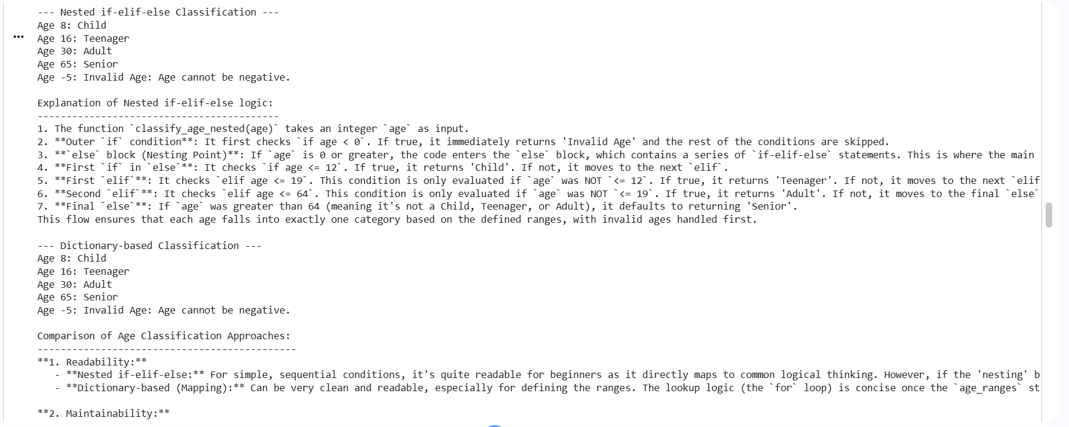
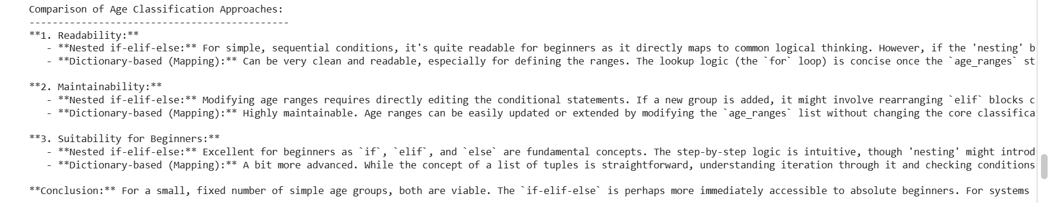

Analysis: The AI-generated solution correctly addresses the given problem using appropriate programming constructs. The logic implemented is clear and easy to understand, making the code suitable for beginners. Core concepts such as loops, conditional statements, or classes are used effectively to solve the task. The structure of the code improves readability and maintains proper flow of execution. Overall, the AI assistance helps in reducing complexity while ensuring correctness.
Task 4:
Prompt: Generate a Python function sum_to_n() to calculate the sum of the first n natural numbers using a for loop. Also suggest an alternative approach using a while loop or formula.
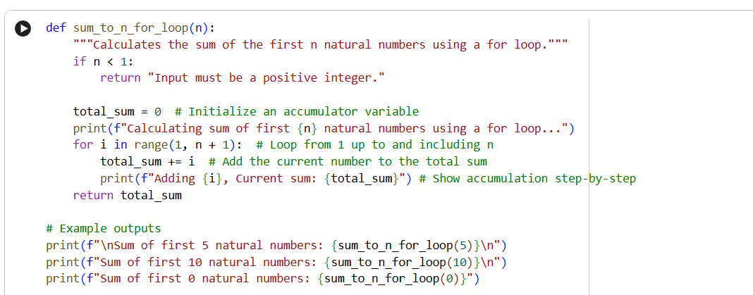

Output:
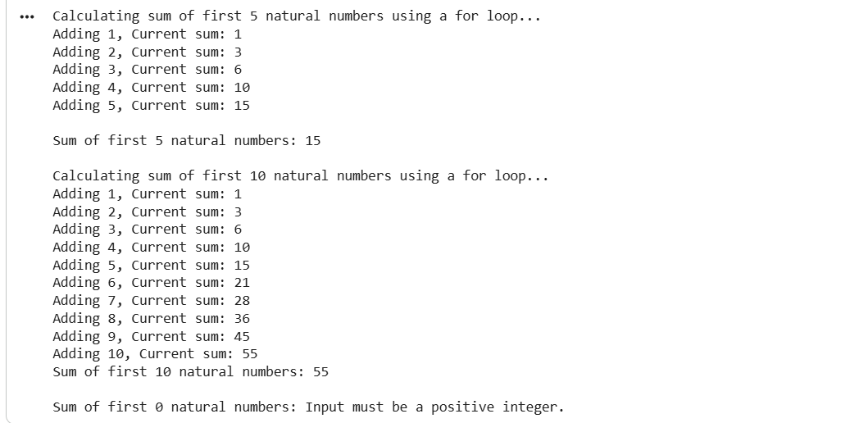
Analysis: The AI-generated solution correctly addresses the given problem using appropriate programming constructs. The logic implemented is clear and easy to understand, making the code suitable for beginners. Core concepts such as loops, conditional statements, or classes are used effectively to solve the task. The structure of the code improves readability and maintains proper flow of execution. Overall, the AI assistance helps in reducing complexity while ensuring correctness.
Task 5:
Prompt: Generate a Python class named BankAccount with methods deposit(), withdraw(), and check_balance(). Demonstrate the working of the class with sample operations.
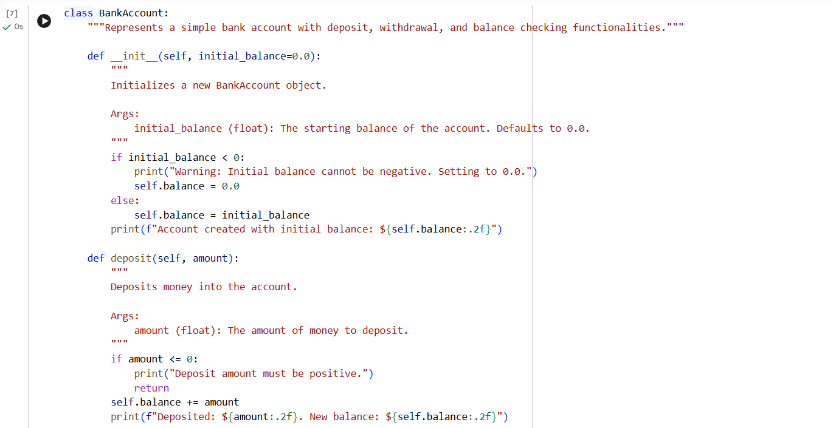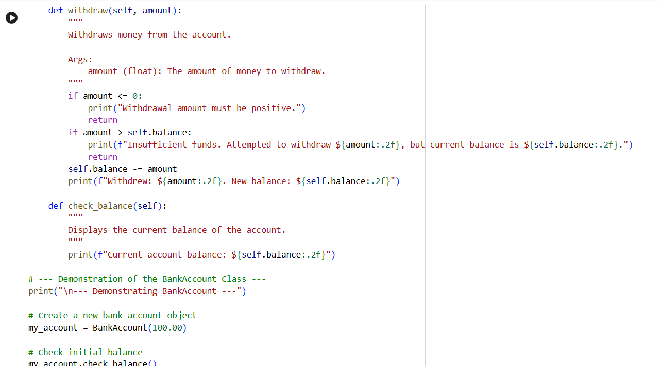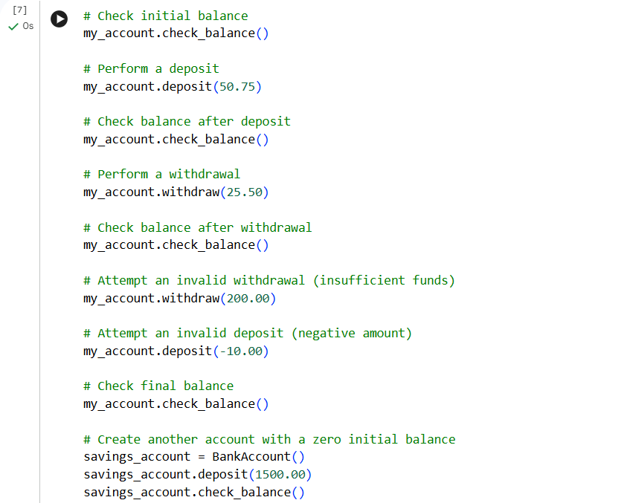

Output:
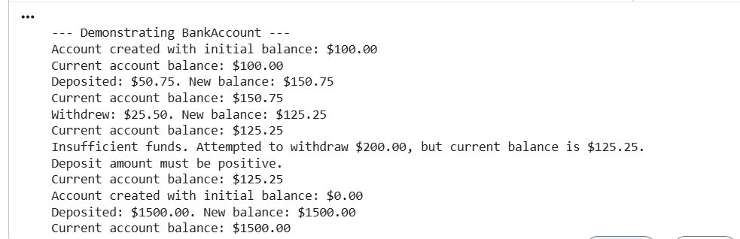
Analysis:
The AI-generated solution correctly addresses the given problem using appropriate programming constructs. The logic implemented is clear and easy to understand, making the code suitable for beginners. Core concepts such as loops, conditional statements, or classes are used effectively to solve the task. The structure of the code improves readability and maintains proper flow of execution. Overall, the AI assistance helps in reducing complexity while ensuring correctness.

